|  |  |
| --- | --- |
| Seats with people at the movies  Rockbuster Stealth LLC  DATA DICTIONARY | Abstract  Rockbuster Stealth LLC is a movie rental company that used to have stores around the world. Facing stiff competition from streaming services such as Netflix and Amazon Prime, the Rockbuster Stealth management team is planning to use its existing movie licenses to launch an online video rental service in order to stay competitive  Bandana Sharma  December 22, 2023 |

Table of Contents

ERD: Entity relationship diagram 2

2.Tables 2

Payment Table 3

Store Table (Dimension Table) 3

Inventory Table (Dimension Table) 3

Film Table (Dimension table) 4

Category (Dimension Table) 5

Actor table (Dimension Table) 5

City Table (Dimension table) 5

Film category Table (Demension Tale) 6

Film_actor Table (Dimension Table) 6

Country Table (Dimension Table) 6

Address Table (Dimension Table) 6

Staff Table (Dimension Table) 7

Customer Table (Dimension Table) 8

Language Table (dimension Table) 8

Rental Table (dimension Table) 9

# ERD: Entity relationship diagram

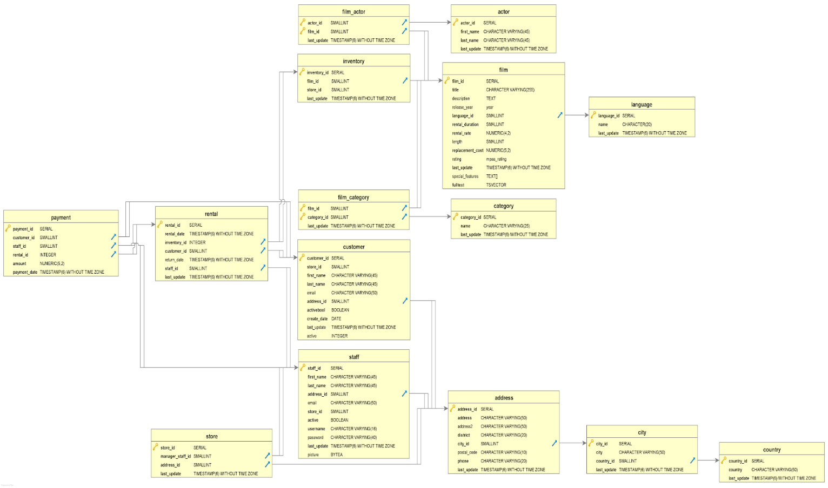

## 2.Tables

Gold Key Primary Key

 Foreign Key

2.1 Fact Table

### Payment Table

|  |  |  |  |
| --- | --- | --- | --- |
|  | Column | Data type | Description |
| Gold Key | Payment_id | Integer | Unique payment Identity |
|  | Customer_id | Smallint | Unique Payment Identity |
|  | Staff_id | Smallint | Uniquie staff Identity |
|  | Rental_id | Integer | Unique rental Identity |
|  | Amount | numeric | Payment amount/ number |
|  | Payment_date | Timestamp without time zone | Payment date and time |

|  |  |
| --- | --- |
| Tables | Join |
| Rental | Payment.customer_id=rental.customer_id |
| Customer | Payment.Customer_id=customer.customer_id |
| Staff | Payment.Staff_id=staff.staff_id |

Link to

### Store Table (Dimension Table)

|  |  |  |  |
| --- | --- | --- | --- |
|  | Column | Data type | Description |
| Gold Key | Store_id | Integer | Unique store id and is a primary key |
|  | Manager_staff_id | Smallint | Unique Manager Identity |
|  | Address_id | Smallint | Unique address Identity |
|  | Last_update | Timestamp without time zone | Last update date and time |

Links to

|  |  |
| --- | --- |
| Tables | Join |
| Staff | Store.address_id=staff.address_id |
| Address | Store.address_id=address.address_id |

### Inventory Table (Dimension Table)

|  |  |  |  |
| --- | --- | --- | --- |
|  | Columns | Data type | Discription |
| Gold Key | Inventory ID | Integer | Primary key of the table: maybe surrogates inventory ID. unique |
|  | Film_id | Smallint | Foreign key of the table: Film identifying number. Connecting to ither table: unique |
|  | Store_id | Smallint | Store identifying number unique |
|  | Last_update | Timestamp without time zone | When the inventory was last update with time. |

Links to

|  |  |
| --- | --- |
| Tables | Join |
| Film | Inventory.film_id=film.film_id |

Link from

|  |  |
| --- | --- |
| Tables | Join |
| Rental | Rental.inventory_id=Inventory.Inventory_id |

### Film Table (Dimension table)

|  |  |  |  |
| --- | --- | --- | --- |
|  | Column name | Data type | description |
| Gold Key | Film_id | Integer | Primary Key: unique ID that connects to other |
|  | Title | Character varying (255) | So VARCHAR(255) variable character of mas 255 letters. Unique title. |
|  | Description | Text | Free text that describes the the film. |
|  | Release date | Integer | Date that the film is release. In number |
|  | Language_id | Smallint | Unique ID for the langue used in the film |
|  | Rental_duration | Smallint | Time that film was rented |
|  | Rental_rate | Numeric | Numeric number to address the rate of the film |
|  | Length | Smallint | Length of the film |
|  | Replacement_cost | Numeric | Cost amount in number if the film were to be lost |
|  | Rating | User_defined | User specific rating of the film |
|  | Last_update | Timestamp without time zone | When was the film last updated |
|  | Special _feature | Array | Any special feature in the film |
|  | fulltext | tsvector | Key description text of film and count of word. |

Links to

|  |  |
| --- | --- |
| Tables | Join |
| Language | Film.language_id=language.Language_id |

Link from

|  |  |
| --- | --- |
| Tables | Join |
| Film_actor | film_actor.film_id = film.film_id |
| Inventory | inventory.film_id = film.film_id |
| Film_category | film_category.film_id = film.film_id |

### Category (Dimension Table)

|  |  |  |  |
| --- | --- | --- | --- |
|  | Column | Data type | Description |
| Gold Key | Category_id | Integer | Unique category Id |
|  | name | Character varying(45) | Name of category with character of only 45 L |
|  | Last_update | Timestamp without time zone | Date and time of the last update |

Links to

|  |  |
| --- | --- |
| Tables | Join |
| Film_cateory | film_actor.category_id = category.category_id |

### Actor table (Dimension Table)

|  |  |  |  |
| --- | --- | --- | --- |
|  | Column | Data type | Description |
| Gold Key | Actor_id | Integer | Unique actor identity |
|  | First_name | Character varying(45) | First name of the actor which holds only 45 character |
|  | Last_name | Character varying(45) | Last name of the actor which holds only 45 character |
|  | Last_update | Timestamp without time zone | Last time and date of update |

Links to

|  |  |
| --- | --- |
| Tables | Join |
| Film_actor | film_actor.actor_id = actor.actor_id |

### City Table (Dimension table)

|  |  |  |  |
| --- | --- | --- | --- |
|  | Column | Data type | Description |
| Gold Key | City_id | Integer | Unique city Identity |
|  | City | Character varying(50) | Name of the specific city that hold only 50 letter |
|  | Country_id | Smallint | Unique country Identity foreign key to connect to country |
|  | Last_update | Timestamp without time zone | Last updated date and time |

Links to

|  |  |
| --- | --- |
| Tables | Join |
| Country | city.country_id = country.country_id |

Link Form

|  |  |
| --- | --- |
| Tables | Join |
| Address | address.city_id = city.city_id |

### Film category Table (Demension Tale)

|  |  |  |  |
| --- | --- | --- | --- |
|  | Column | Data type | Description |
|  | Film_id | Smallint | Unique film Identity |
|  | Category_id | Smallint | Unique Category Identity |
|  | Last_update | Timestamp without time zone | Last updates of date and time |

Links to

|  |  |
| --- | --- |
| Tables | Join |
| Category | film_catogory.catogory_id = category.catogory_id |
| Film | film_catogory.film_id = film.film_id |

### Film_actor Table (Dimension Table)

|  |  |  |  |
| --- | --- | --- | --- |
|  | Column | Data type | Description |
|  | Actor_id | Smallint | Primary key, foreign key |
|  | Film_id | Smallint | Primary key, foreign key |
|  | Last_update | Timestamp without time zone | Last updated date and time |

Links to

|  |  |
| --- | --- |
| Tables | Join |
| Actor | film_actor.actor_id = actor.actor_id |
| Film | film_actor.film_id = film.film_id |

### Country Table (Dimension Table)

|  |  |  |  |
| --- | --- | --- | --- |
|  | Column | Data type | Description |
| Gold Key | Country_id | Interger | Unique country Id and primary Key |
|  | Country | Character varying(50) | Name of the Unique Country name. only 50 |
|  | Last_update | Timestamp without time zone | Date and time last updated |

Links from

|  |  |
| --- | --- |
| Tables | Join |
| City | city.country_id = country.country_i |

### Address Table (Dimension Table)

|  |  |  |  |
| --- | --- | --- | --- |
|  | Column | Data type | Description |
| Gold Key | Address_id | Integer | Unique address Identity (primary key) |
|  | address | Character varying (50) | First Unique address max 50 letter |
|  | Address2 | Character varying (50) | Second Unique address max 50 letter |
|  | district | Character varying (50) | Unique district name max 50 letter |
|  | City_id | smallint | Unique city identity foreign key that connects to City table. |
|  | Postal_code | Character varying (50) | Unique postal code |
|  | phone | Character varying (50) | Unique phone number |
|  | Last_update | Timestamp without time zone | Last time and date address was updated |

Links to

|  |  |
| --- | --- |
| Tables | Join |
| City | address.city_id = city.city_id |

Links from

|  |  |
| --- | --- |
| Tables | Join |
| Store | store.address_id = address.address_id |
| Staff | staff.address_id = address.address_id |
| Customer | customer.address_id = address.address_id |

### Staff Table (Dimension Table)

|  |  |  |  |
| --- | --- | --- | --- |
|  | Column | Data type | Description |
| Gold Key | Staff_id | Integer | Unique staff Identity (primary key) |
|  | First_name | Character varying(45) | Unique first name of the staff |
|  | Last_name | Character varying(45) | Unique last name of the staff |
|  | Address_id | smallint | Unique address of the staff (foreign key they connects to address table) |
|  | Email | Character varying(50) | Unique email off the staff |
|  | Store_id | smallint | Unique store ID of work |
|  | Active | boolean | If staff is active or inactive for job |
|  | Username | Character varying(16) | Unique username for staff |
|  | Password | Character varying(40) | Unique password from staff |
|  | Last_update | Timestamp without time zone | Last time and date of staff |
|  | picture | bytea | Unique picture of the staff |

Links to

|  |  |
| --- | --- |
| Tables | Join |
| Address | staff.address_id = address.address_id |

Linked From

|  |  |
| --- | --- |
| Tables | Join |
| Payment | payment.staff_id = staff.staff_id |
| Store | store.address_id = staff.address_id |
| Rental | rental.staff_id = staff.staff_id |

### Customer Table (Dimension Table)

|  |  |  |  |
| --- | --- | --- | --- |
|  | Column | Data type | Description |
| Gold Key | Customer_id | Integer | Unique customer Identity also primary key |
|  | Store_id | Smallint | Unique store Identity |
|  | First_name | Character varying(45) | Unique customer first name |
|  | Last_name | Character varying(45) | Unique customer last name |
|  | email | Character varying(45) | Unique customer email |
|  | Address_id | smallint | Unique customer id that also connects to address table by foreign key |
|  | Activebool | Boolean | Are customer active or not |
|  | Create_date | Date | Unique date that was created |
|  | Last_update | Timestamp without time zone | Time and date last updated |
|  | active | Integer | Active or not/ |

Link to

|  |  |
| --- | --- |
| Tables | Join |
| Address | customer.address_id = address.address_id |

Link From

|  |  |
| --- | --- |
| Tables | Join |
| Payment | payment.customer_id = customer.customer_id |
| Rental | rental.customer_id = customer.customer_id |

### Language Table (dimension Table)

|  |  |  |  |
| --- | --- | --- | --- |
|  | Column | Data type | Description |
| Gold Key | Language_id | Integer | Primary key has unique language ID |
|  | Name | Character (20) | Language of origin and that limits to 20 characters only |
|  | Last_update | Timestamp without time zone | Tiem and date last updated |

Link From

|  |  |
| --- | --- |
| Tables | Join |
| Film | ilm.language_id = language.language_id |

### Rental Table (dimension Table)

|  |  |  |  |
| --- | --- | --- | --- |
|  | Column | Data type | Description |
| Gold Key | Rental_id | Interger | Unique rental Id: also a primary key |
|  | Rental_date | Timestamp without time zone | Date and time rented by customer and has no time zone |
|  | Inventory_id | integer | Foreign key that connects to another table (inventory table). And is unique inventory ID |
|  | Cuntomer_id | smallint | Also a foreign key that connects to customer table as well and is unique Customer Identity. |
|  | Return_date | Timestamp without time zone | Tiem and date when film are return |
|  | Staff_id | Smallint | It is a foreign key that connects to another table (staff table) |
|  | Last_update | Timestamp without time zone | Date and time when it was last updates. |

Link to

|  |  |
| --- | --- |
| Tables | Join |
| Film | film.language_id = language.language_id |